20170513 Voice Recognition and Speech Sampling using the Arduino

This is a updated version of the

20140703 Voice Recognition and Speech Sampling using the Arduino

Document.

<https://docs.google.com/document/d/16iwYQIy23Hi7es7kr0hopcdpgCetkxZ1nw1-pgxiRoI/edit>

Descent blog posting about “TOP” VR modules

<https://1sheeld.com/top-5-arduino-voice-control-modules/>

Hardware:

Speak Recognition Voice Recognition Module V3 $28.00

<http://www.elechouse.com/elechouse/index.php?main_page=product_info&cPath=168_170&products_id=2254&zenid=j2e8jiv0992ji177gmj3fvbhc2>

I did find a similar module on eBay for $22

This product is a speaker-dependent voice recognition module. It supports up to 80 voice commands in all. Max 7 voice commands could work at the same time. Any sound could be trained as command. Users need to train the module first before let it recognizing any voice command.

This board has 2 controlling ways: Serial Port (full function), General Input Pins (part of function). General Output Pins on the board could generate several kinds of waves while corresponding voice command was recognized.

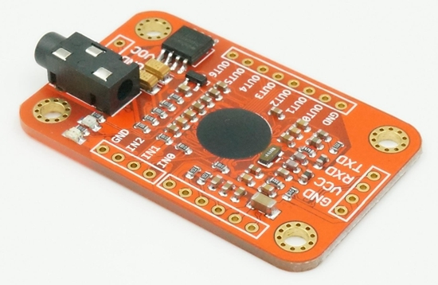

Simple VR Speaker-independent Voice Recognition Module $20.00

<http://www.elechouse.com/elechouse/index.php?main_page=product_info&cPath=168_170&products_id=2263&zenid=mrmd838dr7n81hrnu3ophs40g6>

Also found on eBay for around the $20 price.

**Overview**

Wanna build voice recognition system? Want anyone to use your system without training it in advance? Here comes the SimpleVR voice recognition module.

SimpleVR is a speaker-independent voice recognition module designed to add versatile, robust and cost effective speech and voice recognition capabilities to almost any application.

Different from another voice recognition module [Speak Recognition, Voice Recognition Module V3](http://www.elechouse.com/elechouse/index.php?main_page=product_info&cPath=168_170&products_id=2254&zenid=j2e8jiv0992ji177gmj3fvbhc2), SimpleVR is speaker-independent. You don’t have to train it. And it could recognition standard voice command from any speaker.

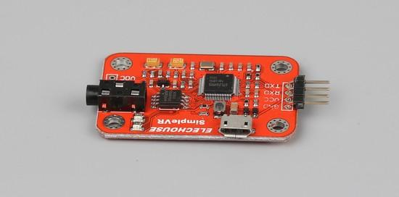

EasyVR3 and EasyVR3 Shield

<http://www.veear.eu/products/easyvr3-shield/>

<http://www.veear.eu/products/easyvr3/>

The EasyVR 3 is a multi-purpose speech recognition module designed to easily add versatile, robust and cost effective speech recognition capabilities to almost any application.

The EasyVR 3 module can be used with any host with an UART interface powered at 3.3V – 5V, such as PIC and Arduino boards. Some application examples include home automation, such as voice controlled light switches, locks, curtains or kitchen appliances, or adding “hearing” to the most popular robots on the market.

<https://www.sparkfun.com/products/13316> $50.00

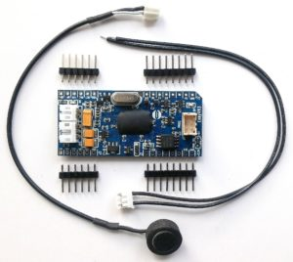

Grove Speech Recognizer

About $20 - Use voice to interact with things around you can always be one of the most interesting things of IoT application, we want to make something more different and cooler

<https://www.seeedstudio.com/Grove-Speech-Recognizer-p-2708.html>

In an Arduino Kit with other Grove Sensors about $40

<https://www.seeedstudio.com/Grove-Speech-Recognizer-kit-for-Arduino-p-2726.html>

ReSpeaker Core

Supports both speech recognition and text to speech and works both on and off line.

<https://www.seeedstudio.com/s/respeaker.html>

1Sheeld Voice Recognition Shield

Using a smart phone and the 1Sheeld shield.

<https://1sheeld.com/shields/voice-recognition-shield/>

Control your Arduino with voice commands with 1 line of code, you can trigger it to control a robot or talk to your home appliances!

Movi Arduino Shield about $75

<http://www.audeme.com/movi.html>

A cloudless Speech Recognizer / Voice Synthesizer for the Arduino platform

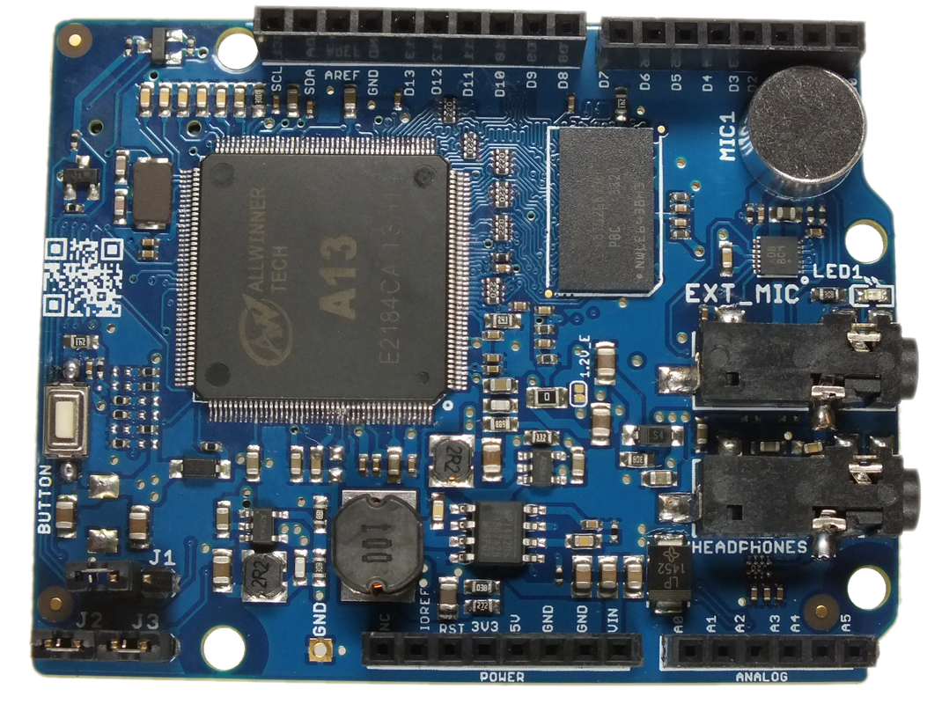

MOVI™ is an easy to use speech recognizer and voice synthesizer. It is used with an Arduino board and provides an alternative to buttons, remote controls, or cell phones by letting you use full-sentence voice commands for tasks such as turning devices on and off, entering alarm codes, and carrying on programmed conversations with projects. MOVI is programmed directly from the Arduino IDE and requires no voice samples for training, does not use an Internet connection and is speaker independent. The code on the left shows an example of how easy it is to create your own voice-based dialog with MOVI.

I’ve written about MOVI before, it’s basically a linux computer that sits on the Arduino and provides VR and speech.